NARCISSE SNAKE DENS

MEDIA INFORMATION

General Information

- The spring emergence can begin as early as the third week in April and run through the month of May. The peak of the emergency and mating activity is generally around the second weekend in May.

- The Narcisse Snake Dens is located in the Interlake region of Manitoba and can be reached by vehicle. The snake den area is situated immediately adjacent to Provincial Trunk Highway #17, approximately 1½ hours north of Winnipeg.

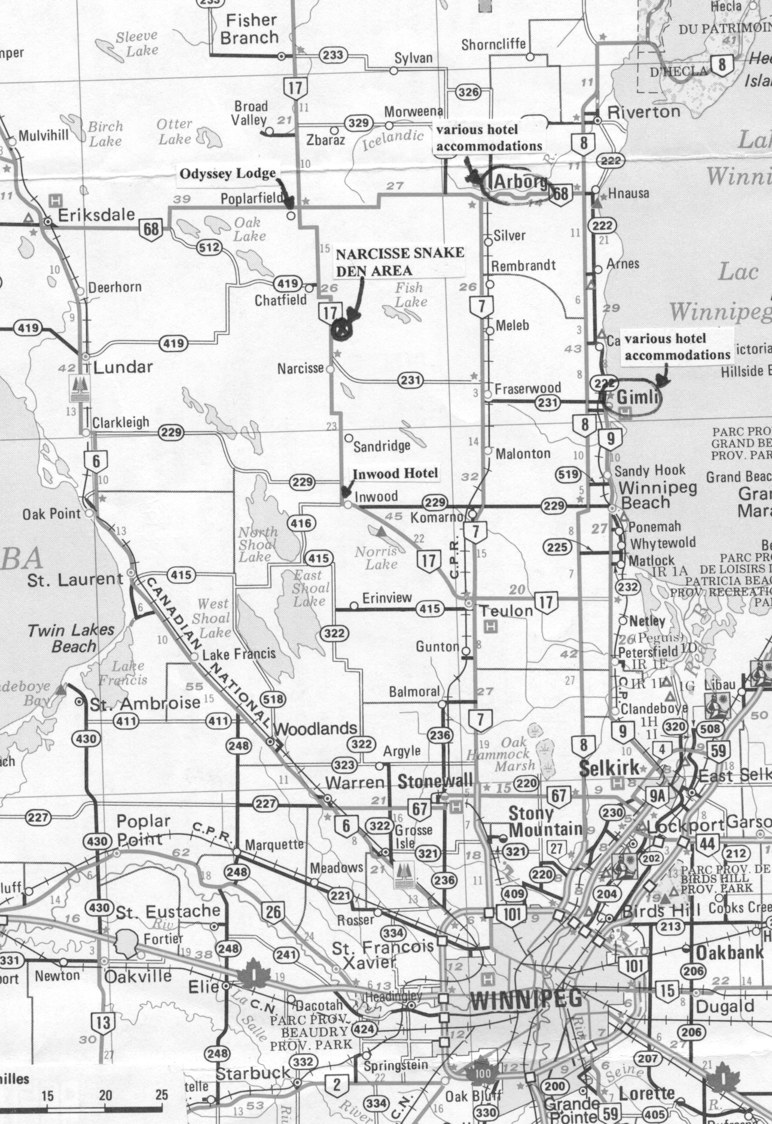

The following is a list of accommodations available in the Interlake area.
Country Harvest Inn, Broad Valley, ph. 204-372-6618
Simply Living Wellness Retreat, ph. 204-278-3611

Lakeview Resort, Gimli, ph. 204-642-8565
The Post & Pelican Bed & Breakfast, Gimli, ph. 1-204-642-4428
Water’s Edge Bed & Breakfast, Gimli, ph. 1-204-642-1497
Gimli Trailer Park & Motel, ph. 204-642-8835
Arborg Zans Family Inn, Arborg, ph. 204-376-5255
Travelling Inn, Arborg, ph. 204-376-5261

- The Manitoba port of entry by air is the James Richardson International Airport, Winnipeg.

- Vehicle rental outlets at Winnipeg International Airport.
Avis – ph. 204-956-2847
Budget – ph. 204-989-8510
Discount – ph. 204-775-2282
Hertz – ph. 204-925-6625
Thrifty – ph. 204-949-7608

Permit and Insurance Requirements

- A Wildlife Management Area Use Permit is required to film within the Narcisse Snake Dens. A WMA Use Permit application can be downloaded from:
http://www.gov.mb.ca/conservation/wildlife/legislation/pdf/wma_appfrm.pdf

- The applicant must provide Manitoba with a Certificate of Insurance in the amount of Two Million Dollars ($2,000,000.00) per occurrence of commercial general liability insurance against claims for personal injury, death or damage to property arising out of the authorized activity. This insurance policy shall name the Province of Manitoba and its officers, employees and agents as Additional Insurers.

Site Operating Conditions

- Public visitation can be very high at times (i.e. 1000 – 3000 people per day) and can be especially crowded on weekends. Some occasional unintentional intrusion from the curious public should be expected and must be tolerated. Filming on weekends is not generally allowed, but may be authorized if absolutely necessary. Filming of red-sided garter snakes in uninterrupted conditions can be arranged at other large den sites in the vicinity.

- Public entry into the dens is prohibited. However, den bottom filming by professional film and television production companies is allowed under the control of a site interpreter or Dave Roberts, Wildlife lands & Habitat Specialist (ph. 204-642-6078). Den bottom filming should be planned for periods before or after the peak visitation (i.e. before 10:00 am and after 2:00 pm) to avoid conflict with visitors. If visitation is expected to be low, this restriction can be relaxed as much as possible. Close communications with a site interpreter or Dave Roberts is required.

- Film and television production crews are expected to exercise extreme caution when working amongst the snakes in the dens. It is suggested that the setting up of film equipment occur prior to the daily emergence (approx. 8:00 a.m.) to reduce movement amongst the snakes. Disturbance of mating balls must be avoided.

- The use of a boom crane to film in a den bottom is only allowed with prior approval from Dave Roberts.

- Public vehicular traffic is prohibited in the Narcisse Snake Dens. Crews must be prepared to carry equipment to the filming site (maximum 0.8 kms from the parking area).

- Be prepared for a wide variety of weather conditions. Spring weather can be quite variable, from snow storms in late April to hot sunny weather later in the month of May. Also, a sturdy pair of hiking boots and waterproof boots is a necessity.

- While first aid supplies are available on site, emergency medical services are at least ½ hour away at the Arborg Hospital or Teulon Hospital.

- For film related logistical assistance contact Ms. Louise O’Brien-Moran, Manager, Film Programs & Location Services, Manitoba Film and Music, 410 – 93 Lombard Avenue, Winnipeg, Manitoba, R3B 3B1, ph. (204)947-2040, e-mail: louise@mbfilmmusic.ca , website: www.mbfilmmusic.ca

- For further site information contact: Dave Roberts, Wildlife Lands & Habitat Specialist, Central Region, Manitoba Conservation, Box 6000, Gimli, Manitoba, R0C 1B0, ph. (204)642-6078, e-mail: Dave.Roberts@gov.mb.ca, website: www.gov.mb.ca/conservation/wildlife/spmon/narsnakes .

Updated: February, 2013

